Arduino UNO
GitHub Repository Structure and Documentation Guidelines

Introduction
Arduino UNO is the most widely used board in the Arduino ecosystem and is usually the first board a student or hobbyist works with. It was originally built around the ATmega328P microcontroller and has since grown into a small family of boards that keep the same physical footprint and pin layout but differ in processing power, memory, and connectivity. Because every UNO variant is pin-compatible with the original, shields and wiring designed for one board generally work across the whole family, which is one of the main reasons it remains the reference platform for teaching embedded systems.

Arduino UNO Family
- UNO R3 - the original and most common version, based on the ATmega328P.
- UNO R4 Minima - the first UNO with a 32-bit microcontroller (Renesas RA4M1), no wireless.
- UNO R4 WiFi - same RA4M1 core as the Minima, plus an ESP32-S3 module for Wi-Fi and Bluetooth, and an onboard 12x8 LED matrix.
- UNO WiFi Rev2 - an ATmega4809-based board with a NINA-W102 Wi-Fi/Bluetooth module, a crypto chip, and an onboard IMU.

UNO R3

1. Features
- Standard, full-size UNO form factor - the reference board for the platform
- ATmega328P 8-bit AVR microcontroller running at 16 MHz
- 14 digital I/O pins, 6 of which support PWM output
- 6 analog input pins
- USB-B connection for programming, power, and serial communication
- Separate ATmega16U2 chip handles USB-to-serial conversion
- Barrel jack and VIN pin for external power
- ICSP header and reset button
- Massive third-party shield and library ecosystem

2. Diagram
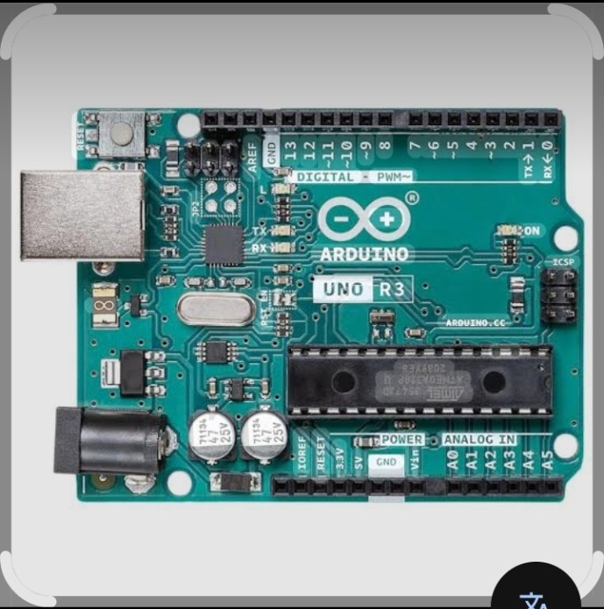
Figure: UNO R3 board layout (illustrative diagram)

3. Specifications
Specification | Value
Microcontroller | ATmega328P
Operating Voltage | 5 V
Input Voltage (recommended) | 7-12 V
Digital I/O Pins | 14 (6 PWM capable)
Analog Input Pins | 6
DC Current per I/O Pin | 20 mA
Flash Memory | 32 KB (0.5 KB used by bootloader)
SRAM | 2 KB
EEPROM | 1 KB
Clock Speed | 16 MHz
USB Interface | USB-B (via ATmega16U2)

4. Advantages
- Simple and beginner-friendly - the most documented Arduino board
- Very low cost and widely available, including many compatible clones
- Huge number of tutorials, libraries, and community projects
- Easy to replace the ATmega328P chip if it gets damaged
- Reliable and well-tested for basic electronics and robotics work

5. Disadvantages
- No built-in wireless connectivity
- Limited flash memory and RAM for larger programs
- 8-bit architecture is slow compared to newer 32-bit boards
- Only one hardware serial port, which can conflict with USB communication

6. Applications
- Learning digital and analog I/O programming
- Simple robotics and automation projects
- Sensor-based mini-projects (LED blink, button, buzzer, potentiometer, etc.)
- Classroom and lab activities
- Prototyping before moving to a more powerful board

UNO R4 Minima

1. Features
- First UNO board with a 32-bit microcontroller
- Renesas RA4M1 (Arm Cortex-M4) running at 48 MHz
- Same UNO form factor and pinout as the R3
- Built-in DAC, RTC, and USB HID support
- USB-C connector for programming and power
- Barrel jack supports up to 24 V input
- Compatible with the Arduino Cloud
- No onboard wireless module (Wi-Fi/Bluetooth)

2. Diagram
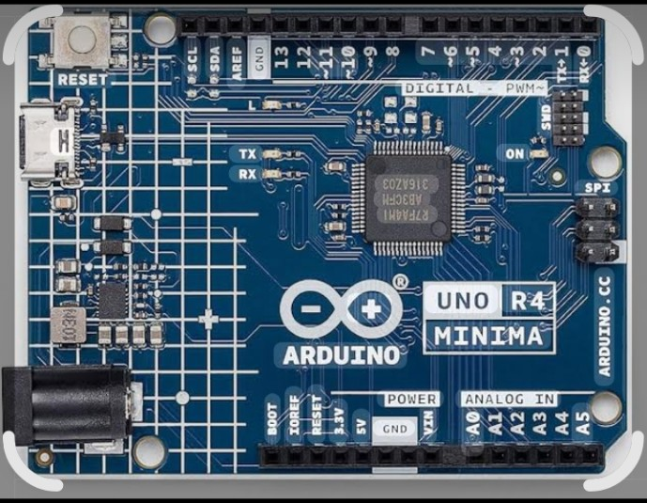
Figure: UNO R4 Minima board layout (illustrative diagram)

3. Specifications
Specification | Value
Microcontroller | Renesas RA4M1 (Arm Cortex-M4)
Operating Voltage | 5 V
Input Voltage (barrel jack) | Up to 24 V
Digital I/O Pins | 14 (6 PWM capable)
Analog Input Pins | 6 (up to 14-bit resolution)
Flash Memory | 256 KB
SRAM | 32 KB
EEPROM | 8 KB
Clock Speed | 48 MHz
USB Interface | USB-C

4. Advantages
- Significant performance and memory upgrade over the R3
- Still fully compatible with existing UNO shields and wiring
- Built-in DAC and RTC remove the need for extra modules in some projects
- Modern USB-C connector
- Higher input voltage tolerance on the barrel jack

5. Disadvantages
- No built-in wireless connectivity (unlike the R4 WiFi)
- Slightly more expensive than the classic R3
- Some very old libraries written for AVR registers may not work directly

6. Applications
- Projects that need more processing power or memory than the R3 offers
- Audio and signal generation projects using the built-in DAC
- Time-based data logging using the onboard RTC
- USB HID projects (keyboard/mouse emulation)
- General prototyping where wireless connectivity is not needed

UNO R4 WiFi

1. Features
- Same RA4M1 core as the UNO R4 Minima, plus wireless connectivity
- ESP32-S3-MINI-1 module for Wi-Fi and Bluetooth Low Energy
- Onboard 12x8 LED matrix for simple visual output
- Qwiic connector for plug-and-play I2C sensors and modules
- CAN bus support
- 12-bit DAC and onboard operational amplifier
- USB-C connector
- Compatible with the Arduino Cloud

2. Diagram
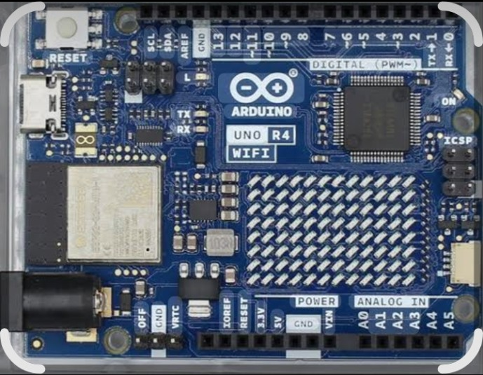
Figure: UNO R4 WiFi board layout (illustrative diagram)

3. Specifications
Specification | Value
Main Microcontroller | Renesas RA4M1 (Arm Cortex-M4, 48 MHz)
Wireless Module | ESP32-S3-MINI-1 (Wi-Fi + Bluetooth LE)
Operating Voltage | 5 V (RA4M1) / 3.3 V (ESP32-S3)
Digital I/O Pins | 14 (6 PWM capable)
Analog Input Pins | 6
Flash Memory | 256 KB
SRAM | 32 KB
EEPROM | 8 KB
Onboard Display | 12 x 8 LED matrix
Communication | I2C, SPI, UART, CAN, Qwiic
USB Interface | USB-C

4. Advantages
- Combines UNO simplicity with real Wi-Fi/Bluetooth connectivity
- Onboard LED matrix is useful for quick status displays without extra wiring
- Qwiic connector speeds up sensor wiring for IoT projects
- Good option for students moving from basic UNO projects into IoT

5. Disadvantages
- More expensive than the R3 and the R4 Minima
- Two microcontrollers on one board adds some complexity for beginners
- Higher power draw than the non-wireless UNO boards

6. Applications
- IoT projects that send sensor data to the cloud
- Home automation and remote monitoring
- Projects needing a simple onboard visual display (LED matrix)
- Bluetooth-controlled robotics
- Final-year or capstone IoT proof-of-concept projects

UNO WiFi Rev2

1. Features
- Based on the ATmega4809 8-bit microcontroller from Microchip
- NINA-W102 Wi-Fi and Bluetooth Low Energy module from u-blox
- ATECC608 secure crypto chip for encrypted/authenticated connections
- Onboard LSM6DS3TR 6-axis IMU (accelerometer + gyroscope)
- Same physical footprint as the UNO R3
- Compatibility layer allows most UNO R3 sketches to run with little or no change

2. Diagram
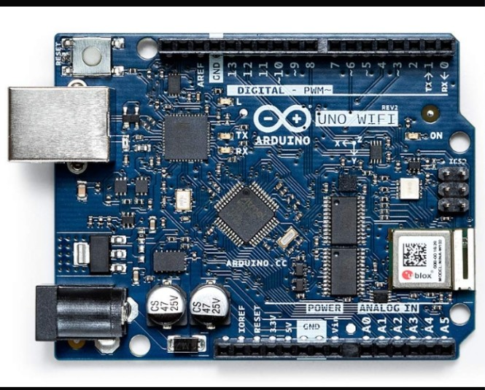
Figure: UNO WiFi Rev2 board layout (illustrative diagram)

3. Specifications
Specification | Value
Microcontroller | ATmega4809
Operating Voltage | 5 V
Input Voltage (recommended) | 6-20 V
Digital I/O Pins | 14 (5 PWM capable)
Analog Input Pins | 6
Flash Memory | 48 KB
SRAM | 6 KB
EEPROM | 256 Bytes
Clock Speed | 16 MHz
Wireless Module | u-blox NINA-W102 (Wi-Fi + BLE)
Security | ATECC608 crypto chip
Motion Sensor | LSM6DS3TR (6-axis IMU)

4. Advantages
- More flash memory and SRAM than the classic R3
- Built-in wireless module without needing an external shield
- Onboard IMU is useful for motion-based projects without extra sensors
- Hardware security chip is useful for secure IoT communication

5. Disadvantages
- Still an 8-bit microcontroller, so it is slower than the R4 family
- Only 5 PWM-capable pins instead of 6 (pin 11 is not PWM enabled on this board)
- Register-level code written for the ATmega328P may need adjustment
- Less community documentation compared to the R3

6. Applications
- Wireless sensor nodes
- Motion-sensing or orientation-based projects using the onboard IMU
- Secure IoT projects that need certificate-based authentication
- Wearable or gesture-control prototypes

Comparison Summary
Board | Microcontroller / Wireless
UNO R3 | ATmega328P, no wireless
UNO R4 Minima | Renesas RA4M1 (32-bit), no wireless
UNO R4 WiFi | Renesas RA4M1 + ESP32-S3, Wi-Fi & Bluetooth
UNO WiFi Rev2 | ATmega4809 + NINA-W102, Wi-Fi & Bluetooth

Connection to Your PoC
For a project that only needs digital I/O and simple sensor readings, the UNO R3 is enough and keeps cost low. If the project needs more memory, a DAC, or faster processing but no wireless features, the UNO R4 Minima is the better fit. If the final proof of concept needs to send data to a phone, app, or the cloud, either the UNO R4 WiFi or the UNO WiFi Rev2 should be used instead, since both include built-in wireless modules and remove the need for an external Wi-Fi/Bluetooth shield.

